

**Report on Design Thinking Project**

Subject : Technology and Information Systems (SECP 1513)

Section : 05

Group : 2

Name of Lecturer : Dr. Azurah A Samah

Date : 29 NOV 2023

Title of Design Thinking Product

: My Wellness Buddy - Personalized Health and Fitness Companion

Video Link (youtube) : <https://youtu.be/Swo6cPLbH1M?si=fgf6PKyQbvpMrrEb>

**Group Profile**

| Name: Ahmed Islam Kassem  Matric Number: A23CS0007  E-mail: [ahmed.qassem.aa7@gmail.com](mailto:ahmed.qassem.aa7@gmail.com)  Phone number: 011-2702 2619  Course: SECJH | Name: Yap En Thong  Matric Number: A23CS0284  E-mail: [enthongy04@gmail.com](mailto:enthongy04@gmail.com)  Phone number: 010-8201396  Course: SECJH | Name: Hu Hao  Matric Number: A23CS4009  E-mail:  [huhao@graduate.utm.my](mailto:huhao@graduate.utm.my)  Phone number: 018-792-523  Course: SECJH |
| --- | --- | --- |
| Name: Muhammad Mujahidul Adli  Matric Number: A22EC4037  E-mail: [m.mujahidul.adli@gmail.com](mailto:m.mujahidul.adli@gmail.com)  Phone number: 011-37916898  Course: SECJH | Name: Chen Shu Yan  Matric Number: A23CS0059  E-mail: [chenshuyan@graduate.utm.my](mailto:chenshuyan@graduate.utm.my)  Phone number: 017-2011393  Course: SECJH |  |

Comments by Grader:

**Table of Contents**

**1.0 Introduction 3**

1.1 Problem Background 3

1.2 Proposed Solution: We launched My Wellness Buddy, an app designed to solve the challenges individuals face in achieving and maintaining a healthy lifestyle. It will become a comprehensive personalised health and fitness companion through various functional functions. 3

1.3 Objective 3

1.4 Scope 3

**2.0 Detailed Steps Related to the Project 4**

2.1 Empathy 4

2.2 Define 4

2.3 Ideate 4

2.4 Prototype 4

2.5 Test 4

2.6 Evidence 5

**3.0 Detailed Descriptions 6**

3.1 Problem 6

3.2 Solution 7

3.3 Teamwork 7

**4.0 Prototype 8**

4.1 User Interface 8

4.2 Description of the App 15

**5.0 Reflection towards Application 16**

**6.0 Task for Each Member 17**

**7.0 Video Link 17**

**8.0 E-portfolio Link 17**

# 

# 1.0 Introduction

## 1.1 Problem Background

Technology has brought us many conveniences, but maintaining a healthy lifestyle can be challenging due to factors ranging from busy schedules to misinformation and a lack of personalised guidance. So we needed a comprehensive and user-friendly solution that could not only track daily activities and provide healthy meals, aka a personalised health and fitness companion.

## 1.2 Proposed Solution

## We launched My Wellness Buddy, an app designed to solve the challenges individuals face in achieving and maintaining a healthy lifestyle. It will become a comprehensive personalised health and fitness companion through various functional functions.

## 1.3 Objective

* Provide comprehensive health tracking methods based on user needs.
* Encourage users to stick to healthier habits over the long term.
* Allow users to comprehensively monitor and manage their health status easily.
* Users can interact with each other to increase user enthusiasm.

## 1.4 Scope

My Wellness Buddy is a Personalized Health and Wellness system with a user-friendly interface. To access the system, users input login information. The homepage suggests exercise movements tailored to user data. The workout page offers diverse exercises to address obesity. The receipt page provides healthy recipes for diet management. The community page facilitates global user interaction for finding workout partners. The My Plan page sets user targets for specific periods.

# 

# 2.0 Detailed Steps Related to the Project

## 2.1 Empathy

Empathy is a stage where developers need to understand the problems met by the users. We interviewed three students from Universiti Teknologi Malaysia to grasp the challenges they face in health and workout routines. Our discussions with the interviewers revealed their issues, providing valuable insights for creating a user-centered application that effectively addresses their unique health and fitness challenges.

## 2.2 Define

Define is a stage where we verify the issues that users are having. After gathering the interviewers' responses, we evaluated the responses to determine all the demands and issues we now face.

## 2.3 Ideate

Ideate is a brainstorming stage where several viewpoints and solutions are gathered to address the problem statement. After discussion, we decided to develop an application called My Wellness Buddy to solve users’ problems.

## 2.4 Prototype

Prototype is a stage for us to identify the best solution and include it in the final product. We developed a user interface for My Wellness Buddy as a demonstration to tackle users’ unique health and fitness challenges.

## 2.5 Test

Testing is a stage that involves testing the prototype to users and gathering their feedback to find product flaws and make necessary improvements.

## 2.6 Evidence

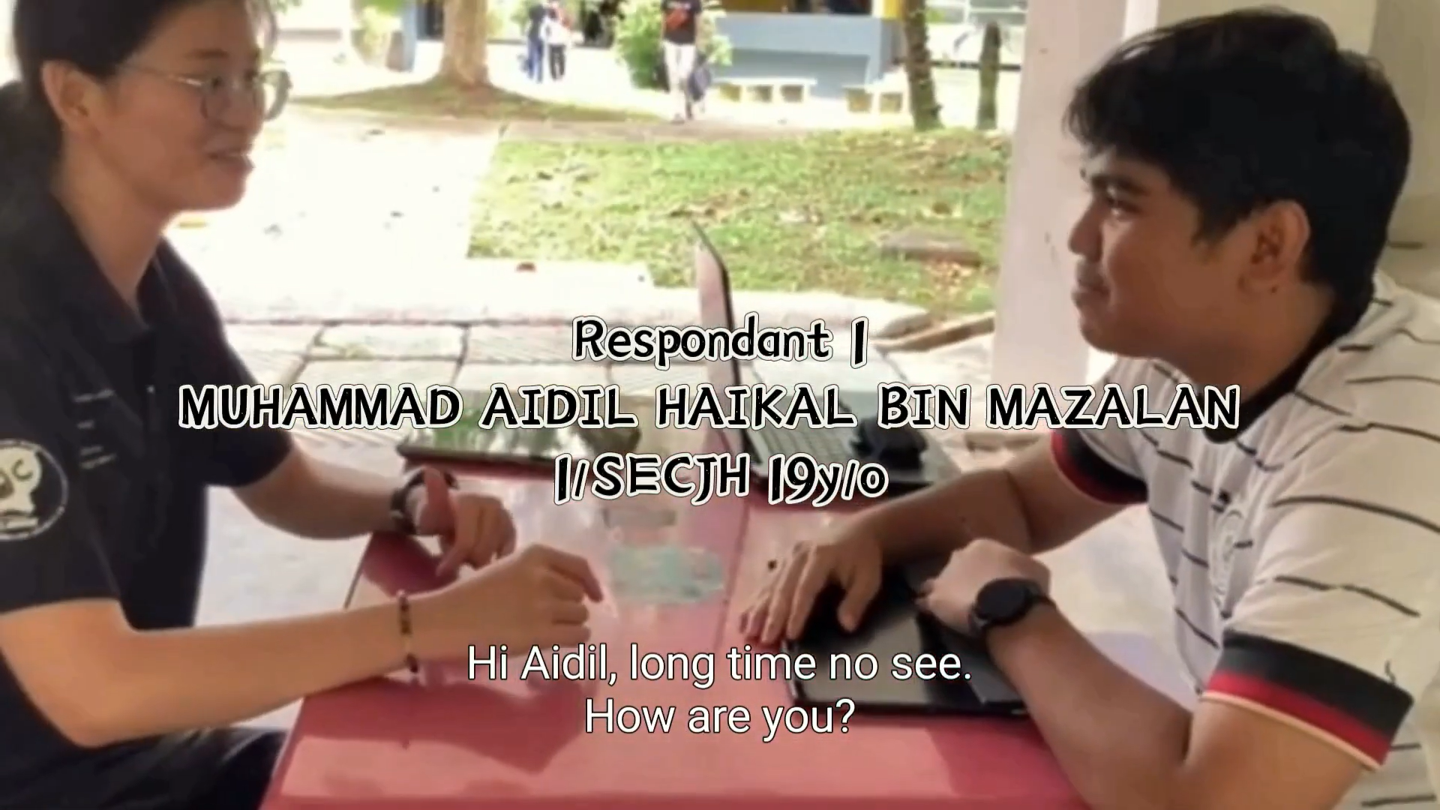

Figure 2.6.1 Interview in the Empathy Stage

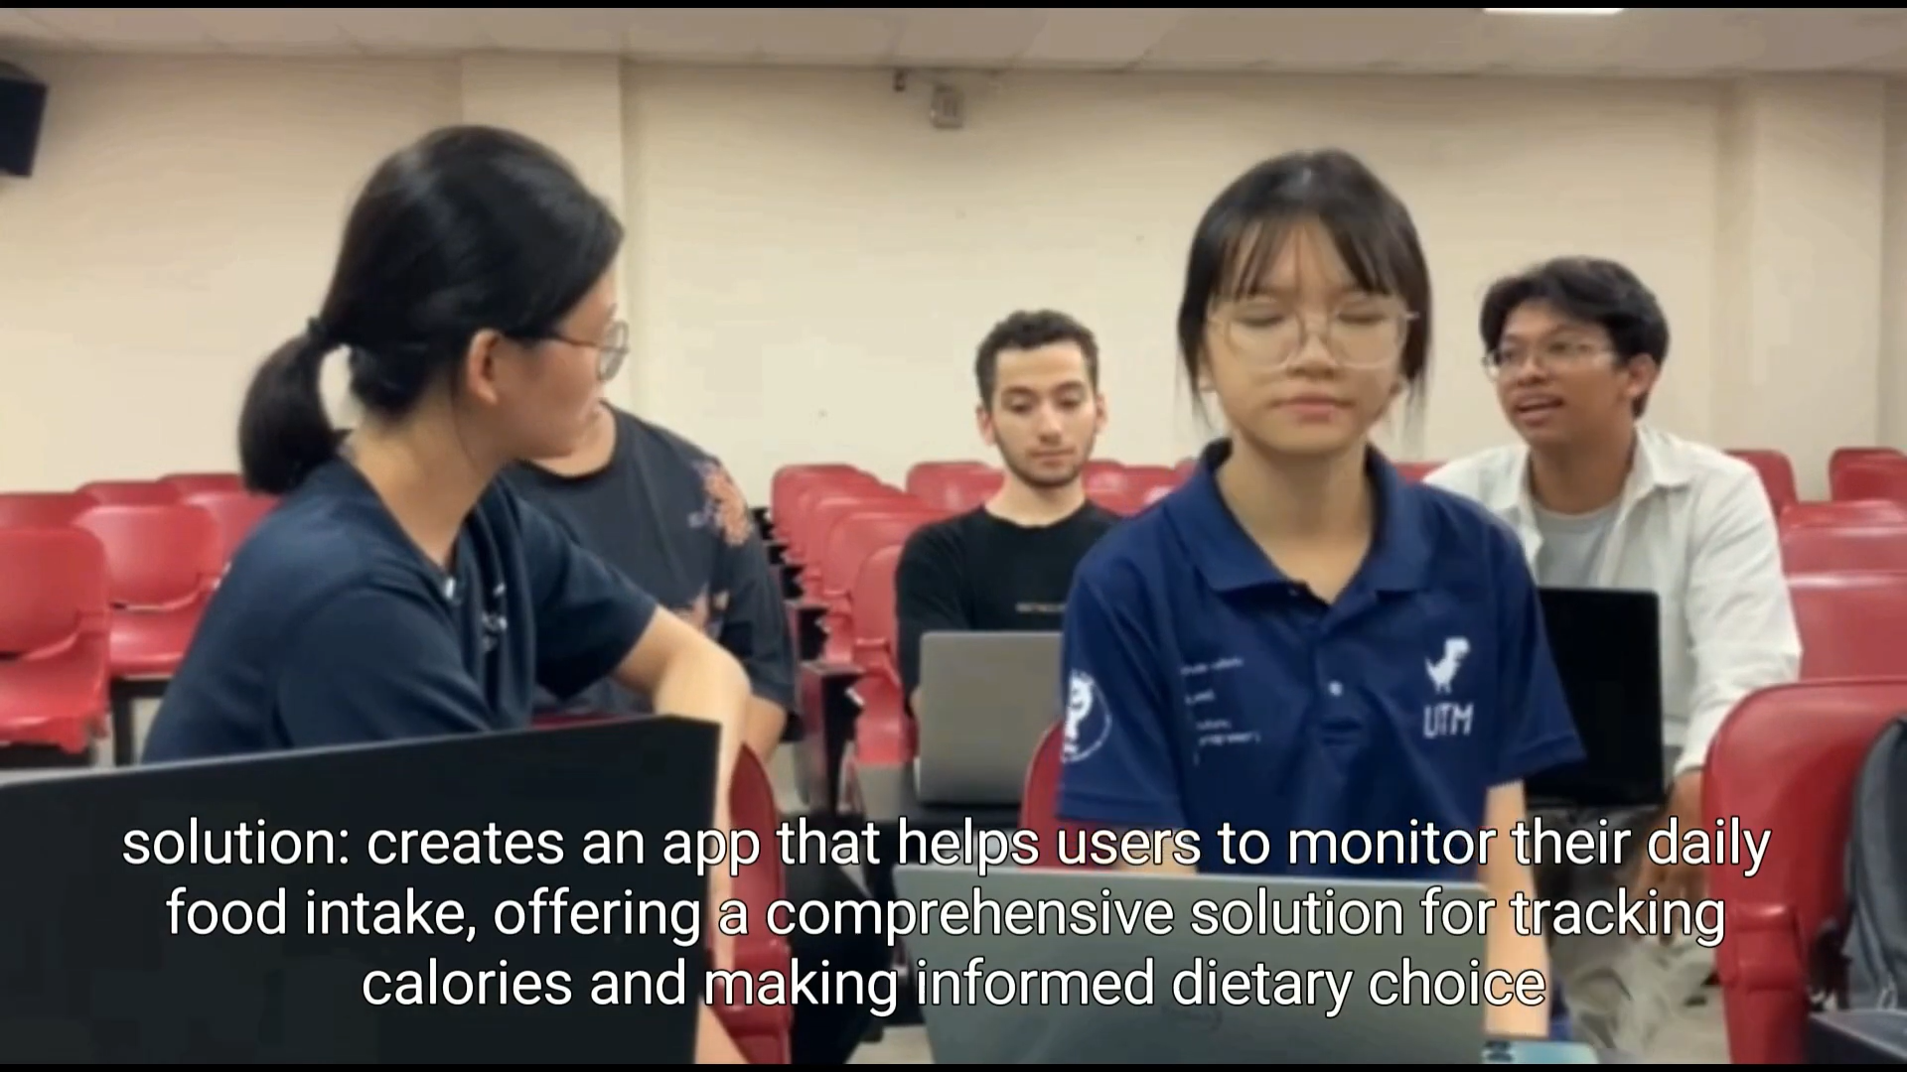

Figure 2.6.2 Discussion during the Define and Ideate Stage

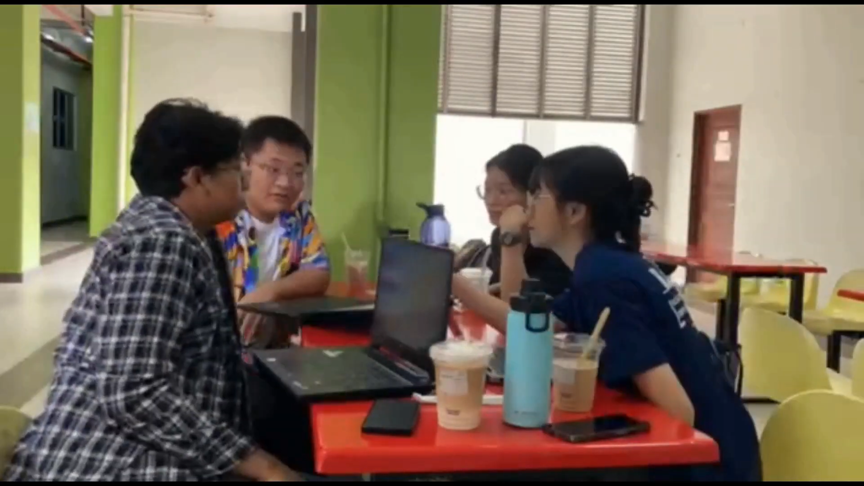

Figure 2.6.3 Developing phase during the Prototype Stage

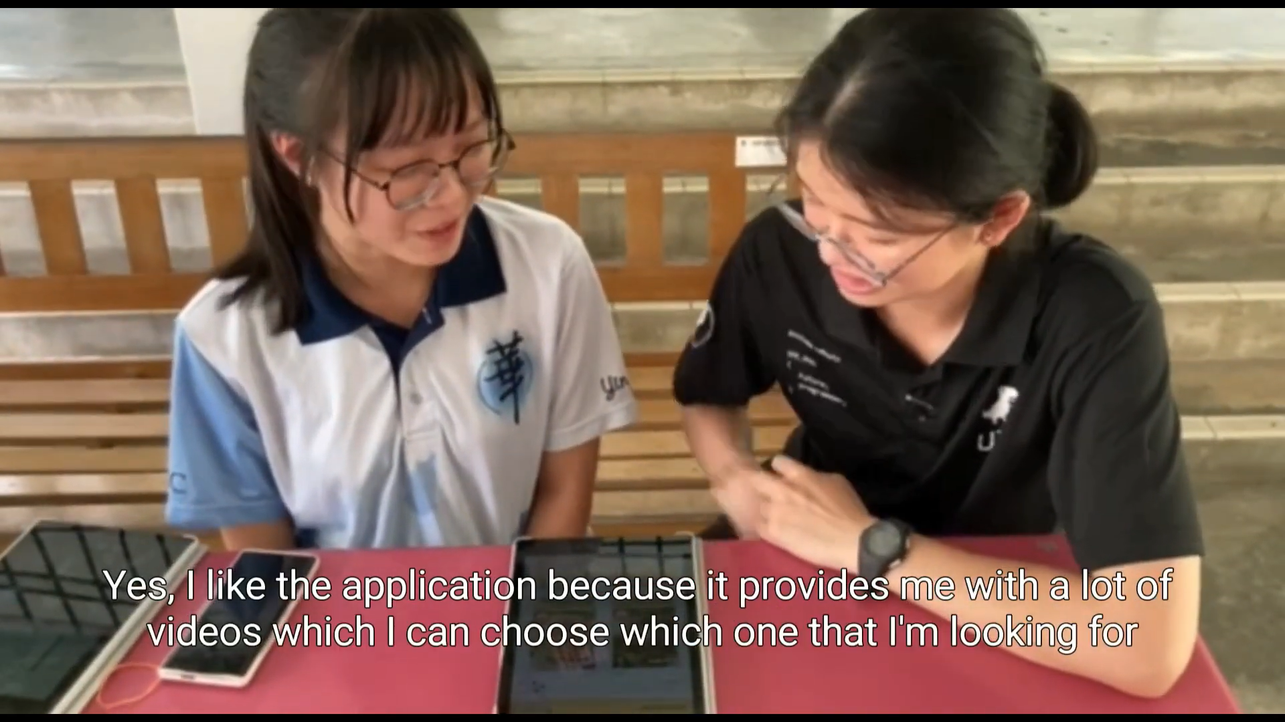

Figure 2.6.4 Test the prototype to the user

# 3.0 Detailed Descriptions

## 3.1 Problem

1. Lack of Personalisation and Customization:
   * Many existing health and fitness apps offer generic workout routines and dietary plans, failing to address the unique needs and preferences of individual users.
   * Users often struggle to find a solution that aligns with their specific fitness goals, dietary restrictions and fitness levels, leading to dissatisfaction and a lack of sustained engagement.
2. Motivation and Accountability Issues:
   * Staying motivated is a common challenge in the fitness journey. Existing apps often lack features that keep users engaged and committed to their fitness routines.
   * Users frequently express a need for personalized motivation, goal tracking and a sense of community to enhance their accountability and make their health and fitness journey more enjoyable.

## 3.2 Solution

1. Personalized Health and Fitness Plans:
   * Our app will revolutionize the health and fitness industry by offering highly personalized workout routines and dietary plans tailored to individual preferences, goals, and constraints.
   * Through a sophisticated algorithm, users will receive recommendations based on their fitness history, health data, dietary preferences and real-time progress, ensuring a customized and effective experience.
2. Motivational Features and Community Building:
   * To address motivation and accountability challenges, our app will incorporate gamification elements, achievement rewards and social features.
   * Users can set and track personalised fitness goals, earn rewards for achievements, and connect with a community of like-minded individuals for support and motivation. This social aspect will create a sense of accountability and make the health and fitness journey more enjoyable and sustainable.

## 3.3 Teamwork

In our group, HU HAO and MUHAMMAD MUJAHIDUL ADLI handled the project introduction, while ADLI and CHEN SHU YAN focused on the video interview. YAP EN THONG focuses on detailed project steps and video editing. AHMED ISLAM MOHAMED EZZELDIN ABDELMOHSEN focuses on reflections. SHU YAN covers problem descriptions, solutions, teamwork and task assignments. Prototype designs are contributed by all members, with EN THONG providing detailed descriptions.

# 4.0 Prototype

## 4.1 User Interface

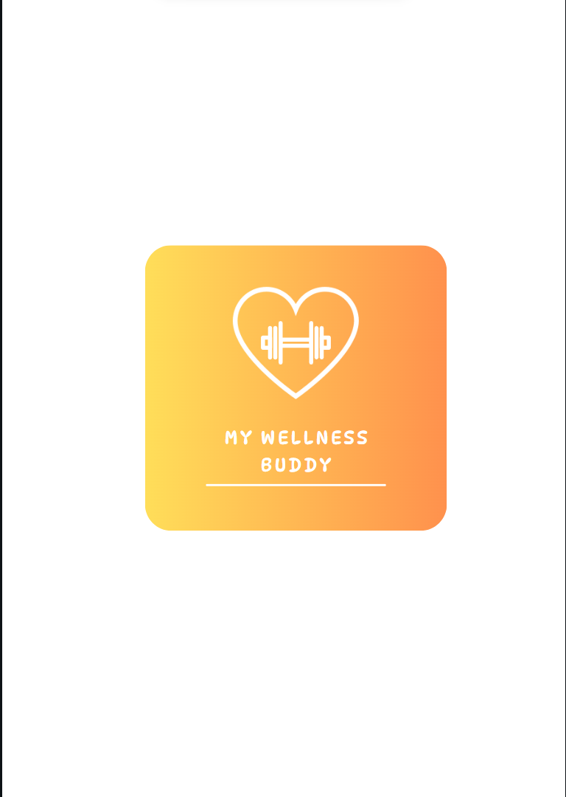

Figure 4.1.1 Logo

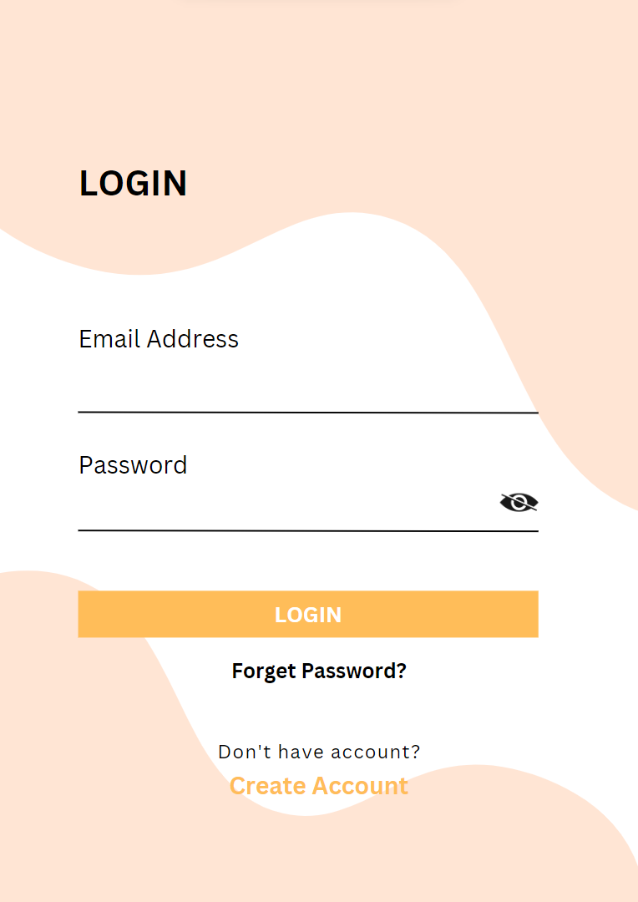

Figure 4.1.2 Login page

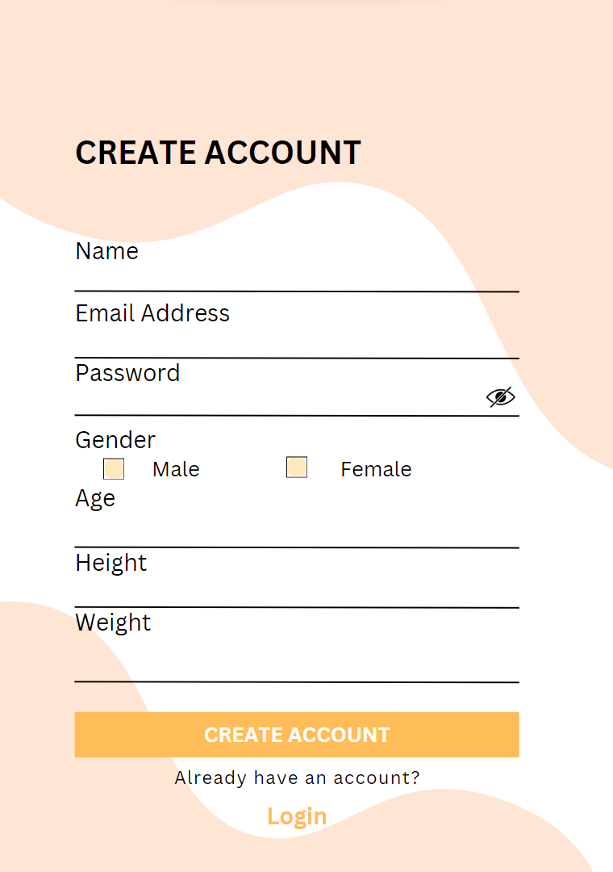

Figure 4.1.3 Create account page

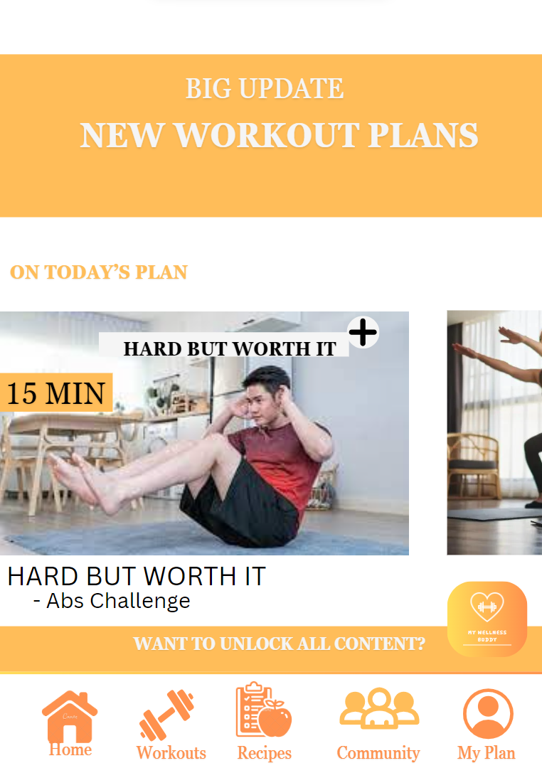

Figure 4.1.4 Home page

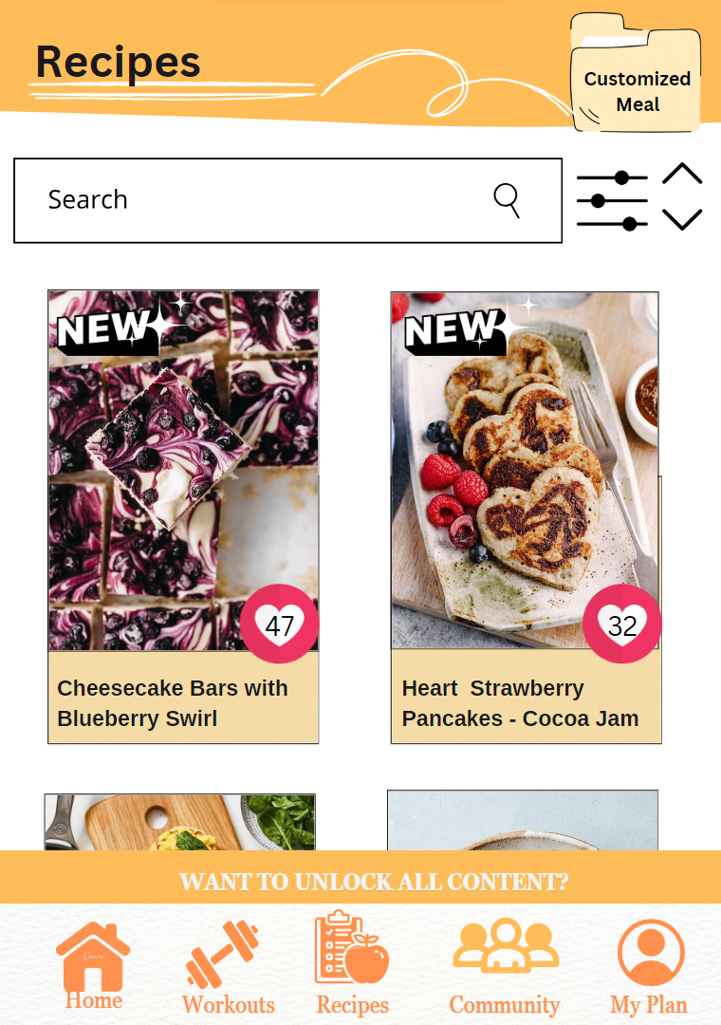

Figure 4.1.5 Recipes page

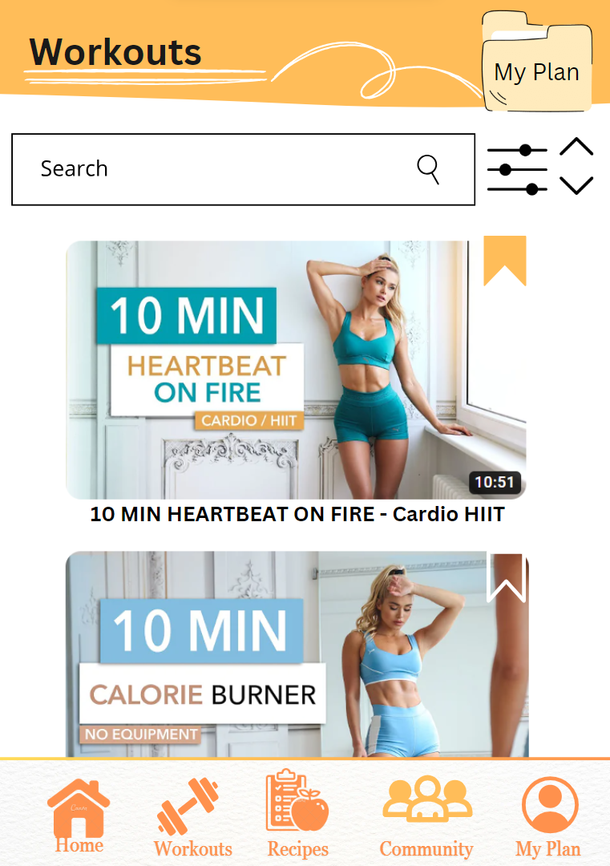

Figure 4.1.6 Workouts Page

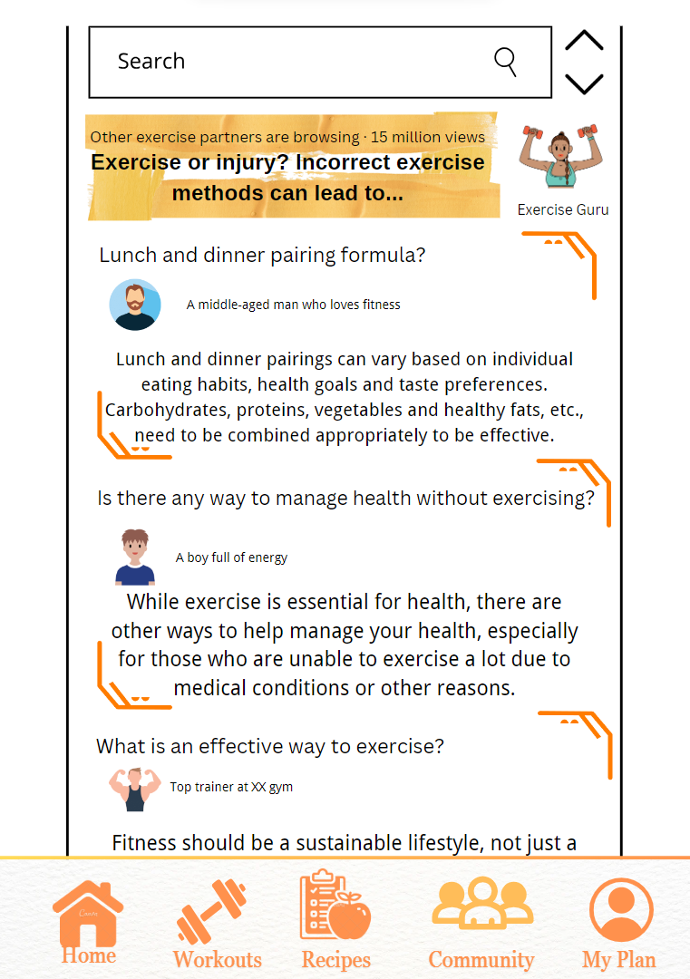

Figure 4.1.7 Community Page

## 

## 

## 

## 

## 

## 

## 4.2 Description of the App

On the Create Account page, beyond the standard email and name inputs, users are prompted to provide essential health details, including age, gender, weight and height. This approach ensures that each user receives a customized experience, optimizing their health journey right from the start.

The Homepage serves as a dynamic hub for users, offering real-time updates on their personalized workout plans and today's fitness challenges. The homepage becomes a central space for users to stay informed, inspired and committed to their health goals.

The recipes page introduces a visually appealing display of diverse food pictures. Users can save their favourite recipes to a personalized meal file for easy access. The inclusion of a search bar allows users to explore a wide variety of recipes and they can even contribute by uploading their own creations. This page seamlessly integrates nutrition into the user's health journey.

The Workouts page is designed for flexibility and personalization. Featuring a search bar, users can find workout videos tailored to their specific needs. The "My Plan" feature allows users to curate a personalized workout schedule, saving preferred videos for easy access. This page empowers users to structure their fitness routines efficiently.

The Community Page serves as a virtual forum where users can share experiences and insights, connect with like-minded individuals. Users can join global clubs such as runner clubs and engage in discussions about workouts and daily routines. Users can gain motivation, advice and a sense of global community, enhancing their overall wellness experience.

# 5.0 Reflection towards Application

In exploring existing health apps such as MyFitnessPal, we drew inspiration that aligns with our prototype, "My Wellness Buddy," particularly in the realm of video-based workouts.

**Key Insights:**

* **MyFitnessPal's Video Workout Integration:** Its effective utilization of video workouts resonates with our approach in "My Wellness Buddy". We aim to offer a diverse library of video-based exercises tailored to individual needs.
* **Personalized Experience:** Both MyFitnessPal and our prototype prioritize personalized user experiences, ensuring that each user’s fitness journey is uniquely tailored from the outset.

**Our Unique Additions:**

My Wellness Buddy distinguishes itself with real-time updates on the Homepage and a "My Plan" feature enabling users to create personalized workout schedules based on their preferred video exercises.

**Future Direction:**

Building on the success of MyFitnessPal and other platforms, our focus is to enhance My Wellness Buddy’s workout section by integrating a wider range of video workouts. By expanding this library and refining the user experience, we aim to create a comprehensive fitness application that combines personalized guidance with a rich variety of video-based exercises for users' benefit.

# 

# 

# 

# 6.0 Task for Each Member

| NAME | MUHAMMAD MUJAHIDUL ADLI | AHMED ISLAM MOHAMED EZZELDIN ABDELMOHSEN | HU HAO | YAP EN THONG | CHEN SHU YAN |
| --- | --- | --- | --- | --- | --- |
| TASKS | Brainstorming | | | | |
| Interview |  |  |  | Interview |
| Prototype design | | | | |
|  |  |  | Video editing |  |
|  |  |  |  | Detailed description related to the project |
|  | Reflection |  |  |  |
|  |  |  | Detail Steps related to the project |  |
| Introduction |  | Introduction |  |  |
|  |  |  | Prototype descriptions |  |

# 7.0 Video Link

<https://youtu.be/Swo6cPLbH1M?si=o71xxRLt-93SLyHf>

# 8.0 E-portfolio Link

<https://eportfolio.utm.my/user/yap-en-thong/design-thinking>

<https://eportfolio.utm.my/user/muhammad-mujahidul-adli/design-thinking>

<https://eportfolio.utm.my/user/hu-hao/design-thinking-1>

<https://eportfolio.utm.my/user/ahmed-islam-mohamed-ezzeldin-a/design-thinking-1>

<https://eportfolio.utm.my/user/chen-shu-yan/design-thinking-1>